GAYATRI VIDYA PARISHAD COLLEGE OF ENGINEERING(A)

**NATIONAL SERVICE SCHEME**

NSS UNITS-GVPCE(A)

AZADI KA AMRIT MAHOTSAV…

**From 1ST AUGUST TO 15TH AUGUST**

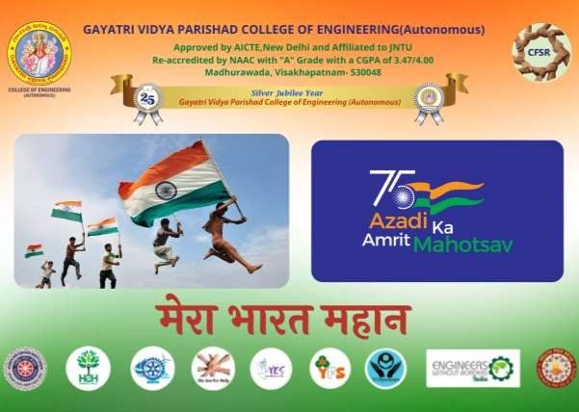

On the occasion of “INDEPENDENCE DAY”, all the clubs of GVPCE(A) unitedly organised the event, Azadi ka amrit mahotsav under the guidance of CFSR. As a part of it NSS unit-1 has organised a series of events like Ralley,Essay-writing,painting competetion, Pin on map certificate and PPT presentations on freedom fighters.

|  |  |  |  |
| --- | --- | --- | --- |
| Activity  conducted by | 90214307 - Gayatri Vidya Parishad College of Engineering(A) Unit-I,  Madhurawada, Visakhapatnam-530 048 | | |
| Activity Type | Other  Event | Title of the Event | Rally |
| Event Start  Date: | 01/08/2022 | Event End Date: | 15/08/2022 |
| Volunteers involved | 618 | Male Volunteers involved: Female Volunteers  involved: | 343  275 |
| Description | NSS UNITS of GVPCE (A) organized rally as a tribute to all our  freedom fighters who fought for our independence. | | |

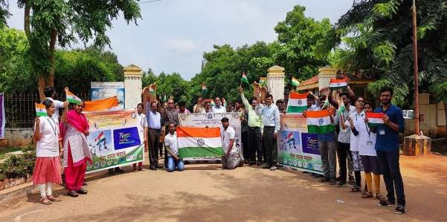

NSS unit-1 initiated the rally as a part of Azadi ka amrit mahotsav and all the clubs joined together and participated in it. The event was organised with lots of energy and with a huge number of participants each of them were given our National flag to hold on at the time of rally, and some of them holds the banners in front and done rally successfully.

As a part of it our respected principal, Dr.A.B.Koteswara rao sir, Dean Student Affairs, Dr.P.KrishnaSubbaraosir, vice principal, Dr. A. Syam sundar, the Associative Director of CFSR, Dr.C.V.Nageswara rao sir, Disciplinary committee head, Dr.P.Krishna Kiran sir, and the Director of Physical education,

Dr.S.S.V.Jagannadha rao sir, and NSS unit-1&2 programme officers, Y.C.V.kondiah sir and Dr.P.Vidhyavati mam were participated in the rally and guided the students and also motivated them.

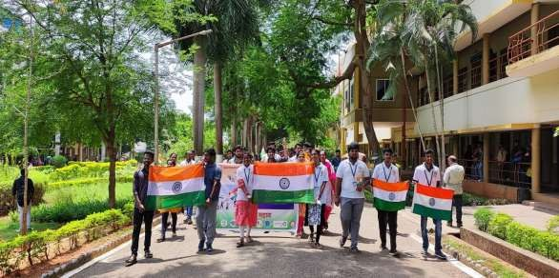

The event was organised with lots of energy and with a huge number of participants each of them were given our National flag to hold on at the time of rally, and some of them holds the banners in front and done rally successfully.

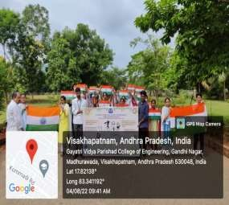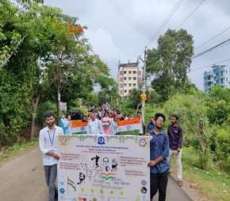

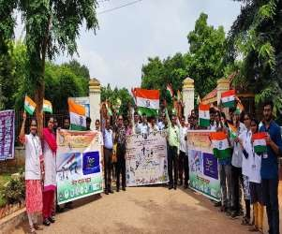 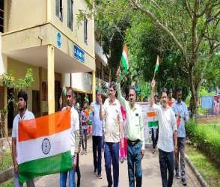

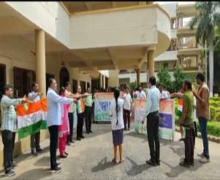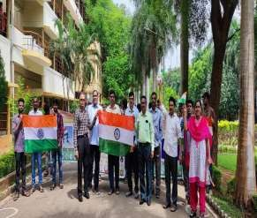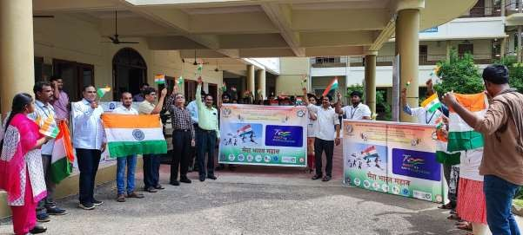

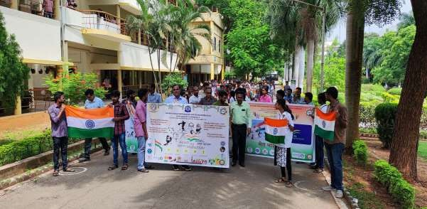

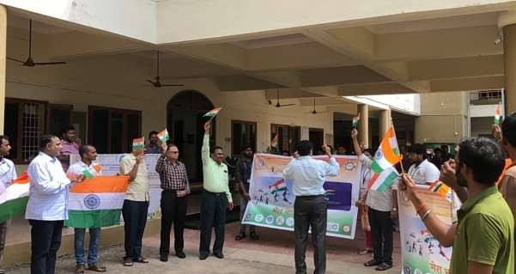

This ralley event was organised from 1st August to 15th August each day one club from our GVPCE(A) took the initiative for the rally event.

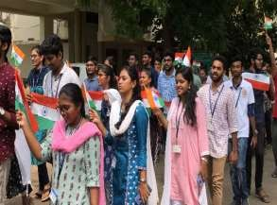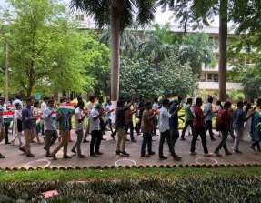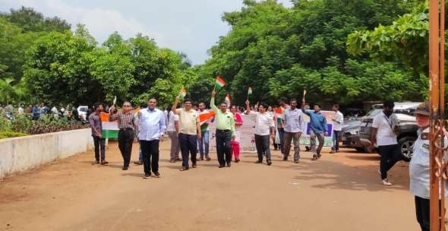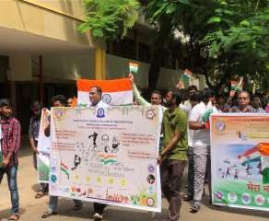 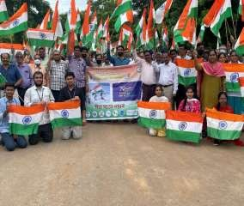

|  |  |  |  |
| --- | --- | --- | --- |
| Activity  conducted by | 90214307 - Gayatri Vidya Parishad College of Engineering(A) Unit-I,  Madhurawada, Visakhapatnam-530 048 | | |
| Activity Type | Other  Event | Title of the Event | Essay writing |
| Event Date: | 04-08-2022 | | |
| Volunteers | 190 | Male Volunteers | 99 |
| involved |  | involved: |  |
|  |  | Female | 91 |
|  |  | Volunteers |  |
|  |  | involved: |  |
| Description | NSS UNITS of GVPCE (A) organized an Essay writing competetion on the themes: Azadi ka amrit mahotsav, Atmanirbhar Bharat, Freedom  fighters & Freedom struggles and Support our troops, Salute our troops. | | |

On 4th August essay writing competetion was also organised by all the clubs unitedly and invited every student by sending google forms to their mails in this event.The competetion was held at the site of our mini auditorium with a huge number of participants.

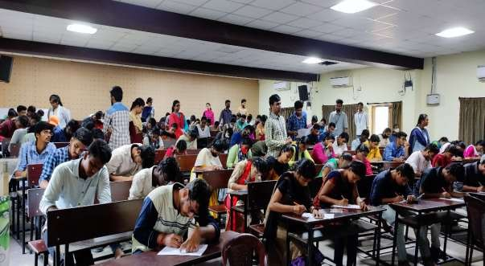

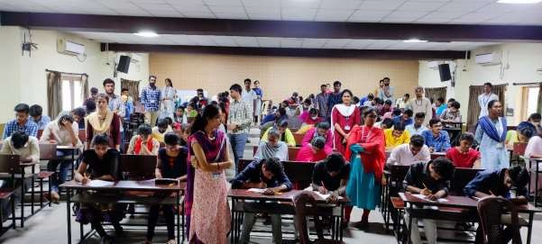

Themes considered for the essay writing are Azadi ka marit mahotsav and sacrifices of freedom fighters, Atmanirbhar Bharat, Freedom fighters and freedom struggles, and Support our troops,Salute our troops.

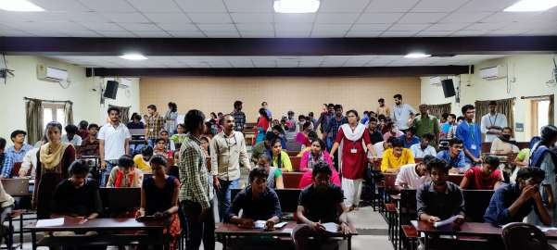

The topics were given on the spot to the students and arranged the requirements for the essay writing like A4 sheets and given the time limit as one hour for them.

|  |  |  |  |
| --- | --- | --- | --- |
| Activity  conducted by | 90214307 - Gayatri Vidya Parishad College of Engineering(A) Unit-I,  Madhurawada, Visakhapatnam-530 048 | | |
| Activity Type | Other  Event | Title of the Event | Painting competition |
| Event Date: | 06-08-2022 | | |
| Volunteers | 151 | Male Volunteers | 75 |
| involved |  | involved: |  |
|  |  | Female | 76 |
|  |  | Volunteers |  |
|  |  | involved: |  |
| Description | NSS UNITS of GVPCE (A) organized a painting competetion on the themes: Azadi ka amrit mahotsav, Atmanirbhar Bharat, Freedom fighters  & Freedom struggles and Support our troops, Salute our troops. | | |

As a part of Azadi ka amrit mahotsav, a painting competetion was held organised in our college on the day 6th August ,2022. All the clubs were unitedly pasricipated in volunteering and the students were given the themes on the day before the art exhibition so that they will be ready to expose their arts.

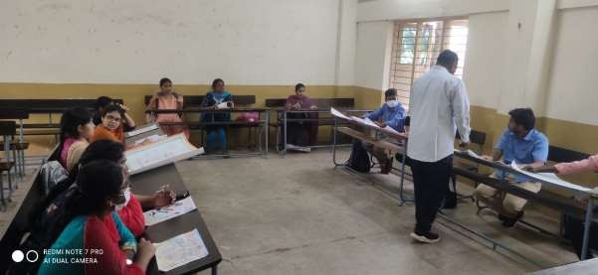

Arrangements were made at the site of our college and all the arts were made exposed for the students and lecturers to watch at and give their feedback on the arts. Also the participants explained their arts for each and every visiter.

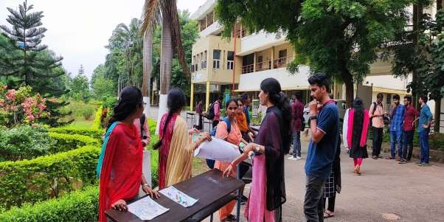

This is done from around 1:30 pm to 5:30 pm for all the visiters to watch the arts and some of them gave appreciations for the participants for their talent in doing arts.

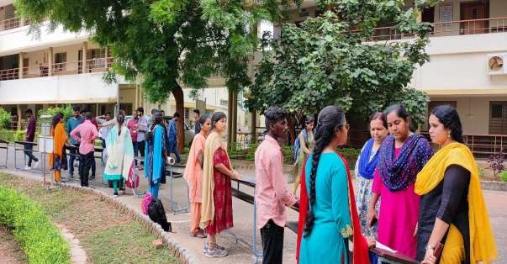

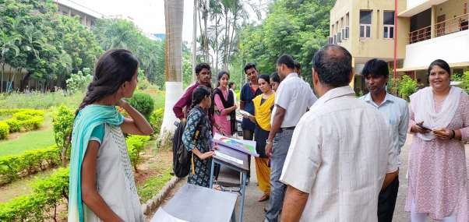

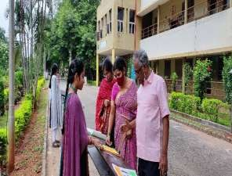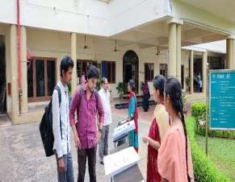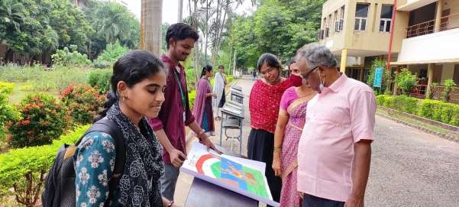

|  |  |  |  |
| --- | --- | --- | --- |
| Activity  conducted by | 90214307 - Gayatri Vidya Parishad College of Engineering(A) Unit-I,  Madhurawada, Visakhapatnam-530 048 | | |
| Activity Type | Other  Event | Title of the Event | PPT Presentation |
| Event Start  Date: | 01/08/2022 | Event End Date: | 15/08/2022 |
| Volunteers | 40 | Male Volunteers | 15 |
| involved |  | involved: |  |
|  |  | Female | 25 |
|  |  | Volunteers |  |
|  |  | involved: |  |
| Description | NSS UNITS of GVPCE (A) organized an online event PPT Presentation  on freedom fighters. | | |

NSS Unit-1 has also organised the online event, PPT Presentation on Freedom fighter from the day 1st August to 15th August at 6:30 p.m. and invited all the club members to participate in this event.

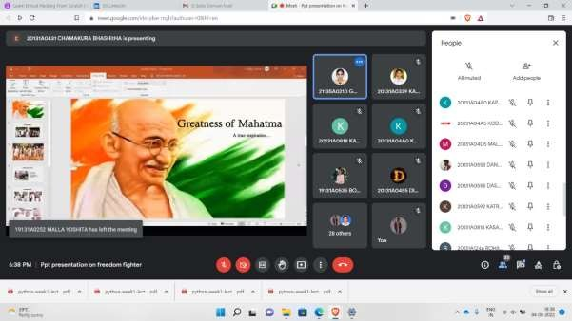

Volunteers in NSS Unit-1 has participated in presenting the PPT’s on freedom fighters and explained their greatness and some even explained the difficulties how they have come across the situations at the time of freedom movements.

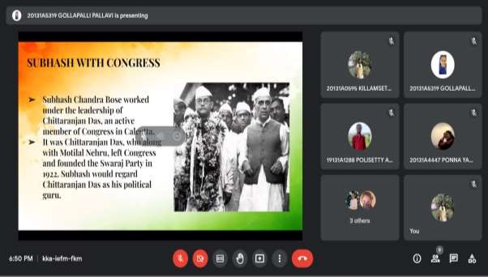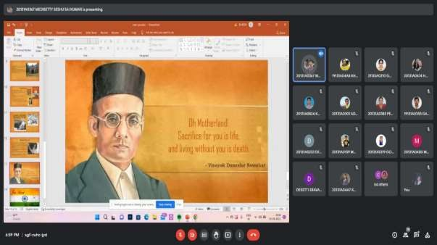

Also, the volunteers from other clubs took part in presentations and made the event successful by recollecting the greatness of our freedom fighters once again and by showing their bravery with some short videos inserting in the presentations.

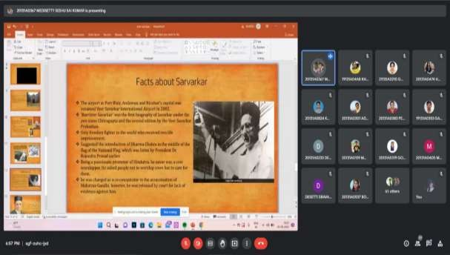

As a part of the presentation the volunteers not only discussed about their great ness and struggles. They also discussed about their vision, ideology in order to achieve freedom.

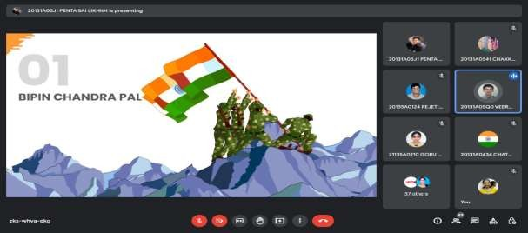

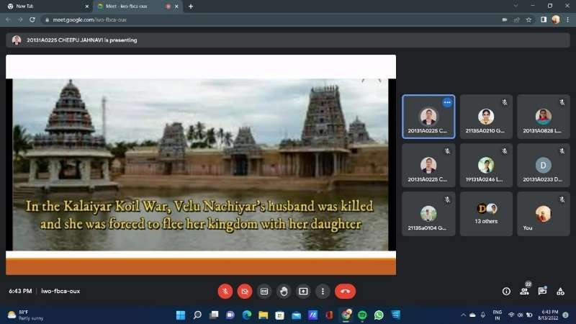

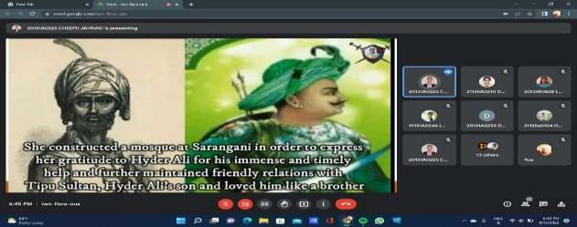 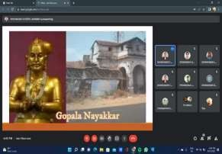

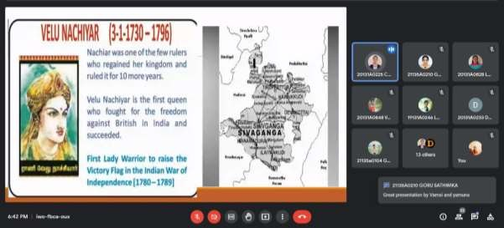

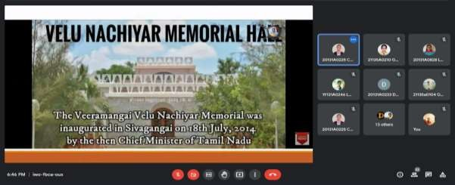



|  |  |  |  |
| --- | --- | --- | --- |
| Activity  conducted by | 90214307 - Gayatri Vidya Parishad College of Engineering(A) Unit-I,  Madhurawada, Visakhapatnam-530 048 | | |
| Activity Type | Other  Event | Title of the Event | Pin the flag |
| Event Start  Date: | 01/08/2022 | Event End Date: | 15/08/2022 |
| Volunteers involved | 250 | Male Volunteers involved: Female Volunteers  involved: | 130  120 |
| Description | NSS UNITS of GVPCE (A) organized an online event Pin a Flag as a  part of “Har Ghar Tiranga”. | | |

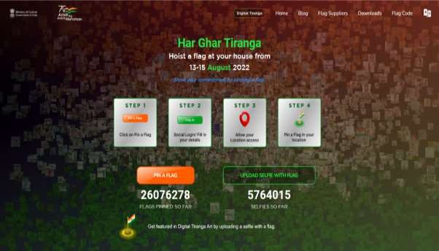

On the occasion of Azadi ka amrit mahotsav Pin on map event was also organised by NSS unit-1. All the participants were sent a link [http://harghartiranga.com](http://harghartiranga.com/) to pin a flag on their location and virtual certificates were given for the participants for pinning the Flag on the map.

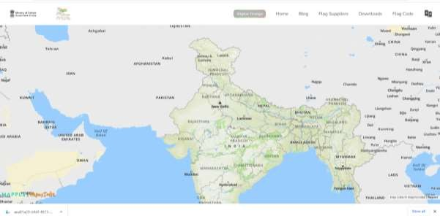

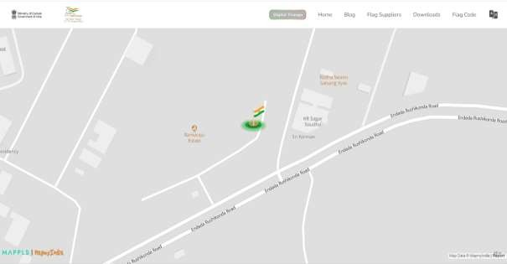

Also the responses were collected from the participants by sharing a google form for them to upload the certificates for pinning the flag.This event was organised a s a part of Har Ghar Tiranga.

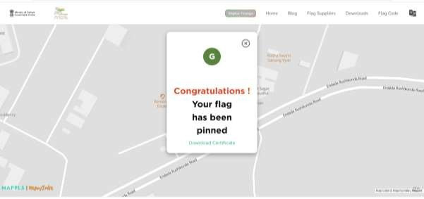

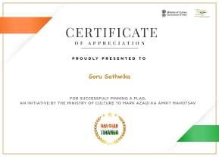 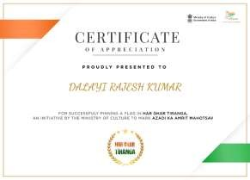

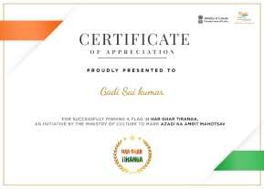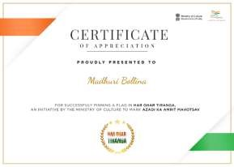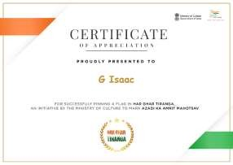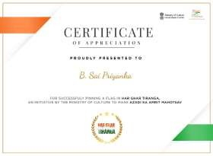

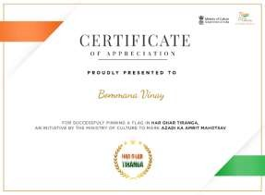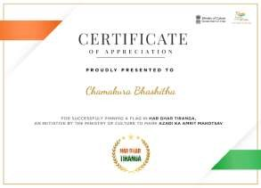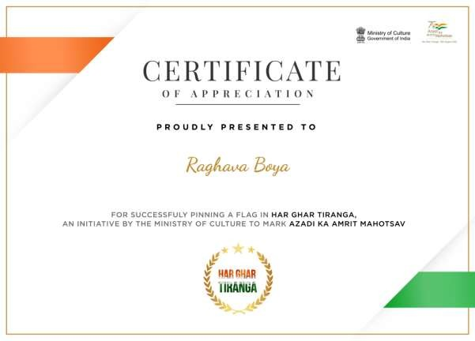

All the events organised were done successfully with huge number of participants and made the events of Azadi ka amrit mahotsav a grand success.

|  |  |  |  |
| --- | --- | --- | --- |
| Activity  conducted by | 90214307 - Gayatri Vidya Parishad College of Engineering(A) Unit-I,  Madhurawada, Visakhapatnam-530 048 | | |
| Activity Type | Other  Event | Title of the Event | Quiz competition |
| Event Start  Date: | 11-08-2022 | | |
| Volunteers | 500 | Male Volunteers | 280 |
| involved |  | involved: |  |
|  |  | Female | 220 |
|  |  | Volunteers |  |
|  |  | involved: |  |
| Description | NSS UNITS of GVPCE (A) organized a quiz competition in online  mode as a part of Azadi ka amrit Mahotsav. | | |

On the occasion of Azadi ka amrit mahotsav Quiz competition was organised by NSS unit-1. A huge number of students participated in the event. Indian independence, freedom fighters, important dates of Indian history were the topics which we had considered for the event. As a part of it 6 whatsapp groups were created for each batch of 100 participants.

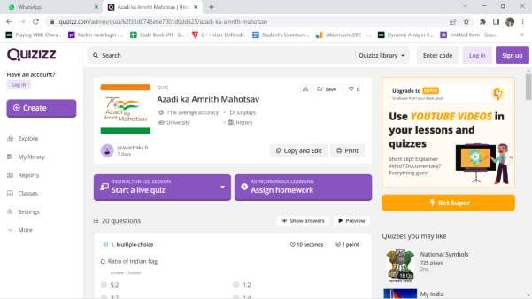

All the instructions were shared to the participants before the day before the competetion. It consists of 20 multiple choice questions each question can be displayed for 10n seconds. The link for the quiz is shared in each whatsapp groups at 6p.m and continuously checked the status of the participants.

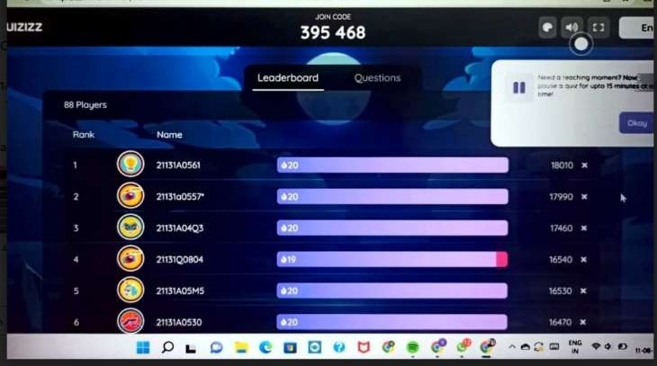

At the end, google forms were circulated to all the participants to upload the screenshots of their position in the quiz.

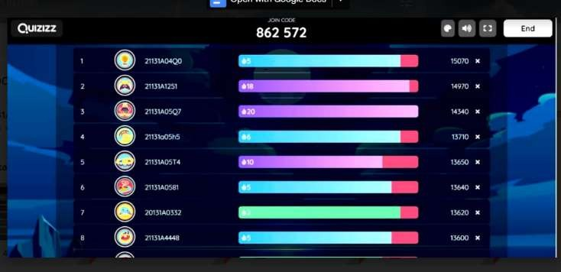

The participants were filtered based on their performance from each batches.

|  |  |  |  |
| --- | --- | --- | --- |
| Activity  conducted by | 90214307 - Gayatri Vidya Parishad College of Engineering(A) Unit-I,  Madhurawada, Visakhapatnam-530 048 | | |
| Activity Type | Other  Event | Title of the Event | Blood donation camp |
| Event Start  Date: | 11/08/2022 | | |
| Volunteers | 200 | Male Volunteers | 130 |
| involved |  | involved: |  |
|  |  | Female | 70 |
|  |  | Volunteers |  |
|  |  | involved: |  |
| Description | NSS UNITS of GVPCE (A) organized a blood donation camp as a part  of Azadi ka amrit Mahotsav. | | |

On the occasion of Azadi ka amrit mahotsav blood donation camp was also organised by our Gayatri Vidya Parishad college of engineering in the main auditorium on 11th august.

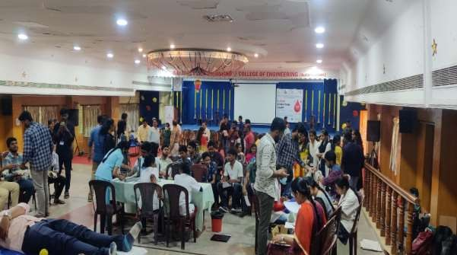

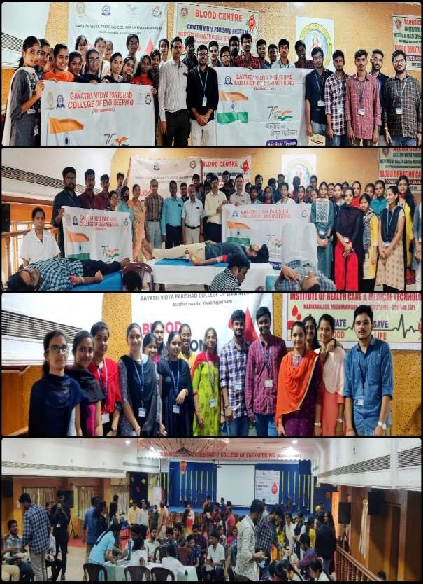

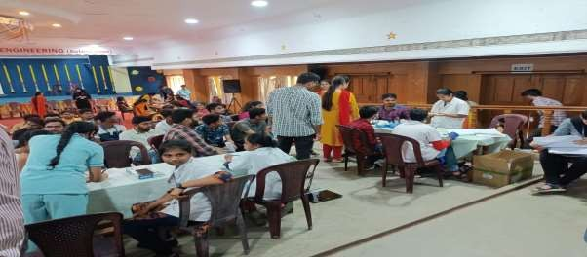 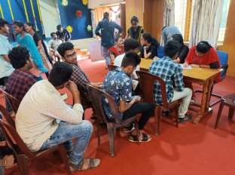

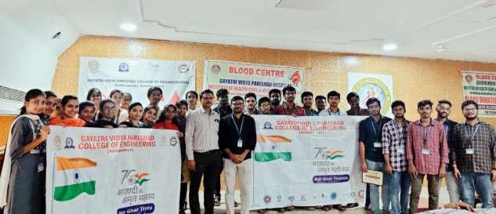

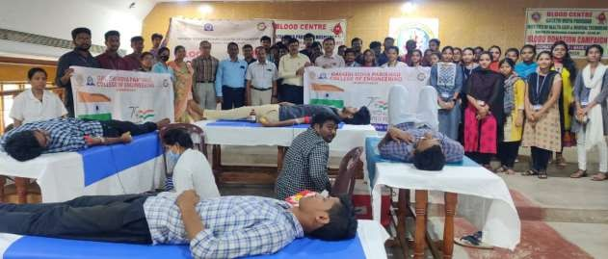

The medical management of the blood banks have tested all the donors to ensure the levels of haemoglobin and blood pressure and measured weights such that a decision can be taken whether the person is strong enough to donate the blood or not.



All the necessary arrangements were made for the donors during entire blood camp. More than 200 donors were registered in the blood camp and made it successful.

|  |  |  |  |
| --- | --- | --- | --- |
| Activity  conducted by | 90214307 - Gayatri Vidya Parishad College of Engineering(A) Unit-I,  Madhurawada, Visakhapatnam-530 048 | | |
| Activity Type | Other Event | Title of the Event | Flag hosting |
| Event Start  Date: | 15/08/2022 | | |
| Volunteers | 200 | Male Volunteers | 120 |
| involved |  | involved: |  |
|  |  | Female | 95 |
|  |  | Volunteers |  |
|  |  | involved: |  |
| Description | ALL THE CLUBS OF GVPCE (A) organised flag hosting on  Independence Day (15th august) | | |

On the occasion of Independence Day, Gayatri Vidya Parishad college of engineering hosted our national flag at 8:45 a.m. In our college premises by our principal, A.B.Kotesawara rao sir, and our chief guest, Dr.P.Raja Ganapthi sir, and other officials during this everyone saluted the flag and sang our national anthem janganamana.All the arrangements were done the day before the event and all the students and faculty were invited to take part in this event.

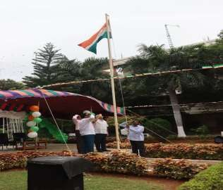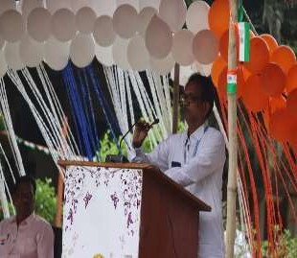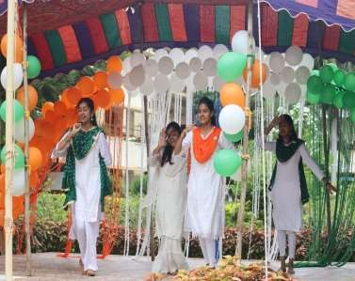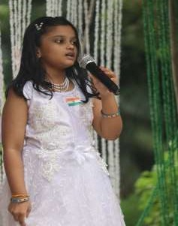

On this occasion mini flags and caps with our flag colours were distributed to each and every person participated in the event meanwhile our NSS Unit-1 made a grand welcome to the principal sir and our chief guest and to other officials.

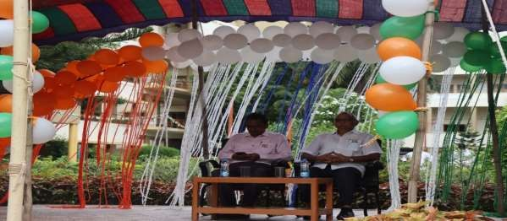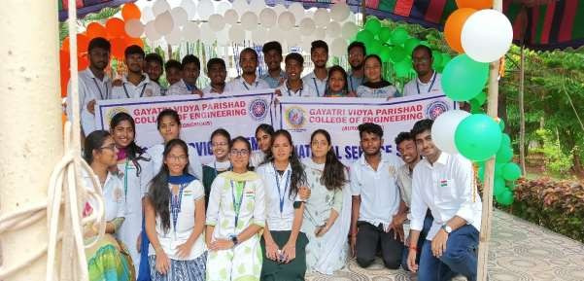

After completion of flag hosting valuable messages were given by our principal sir and our chief guest and later on the singing and dance performances were organised by the cultural club of Gayatri vidya parishad college of engineering.

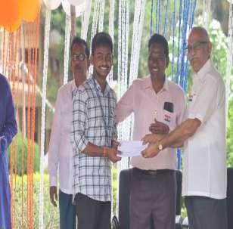 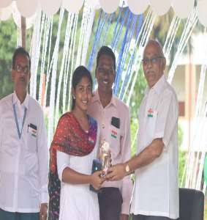

As a part of the Azadi ka amrit Mahotsav many events were organised and competetions like art, essay writing and quiz were conducted by our Gayatri Vidya Parishad College of Engineering and all the winners were given awards by our principal sir and appreciated them.

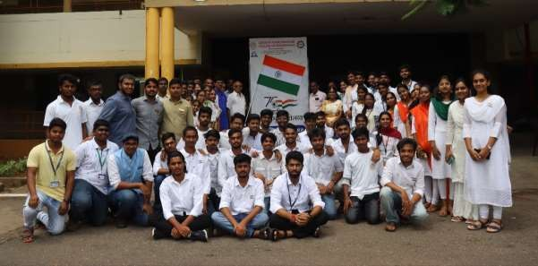

***Service which is rendered without joy helps neither the servent nor the server.***

